# Fitness Tracker Products Analysis Report

***Anh Quan Hua***

## 1. Introduction

*Problem statement:* With Redback Operations aiming to create smart, high-tech environments that incentivize exercising, it is not far-fetch to assume that smart wearables will be an essentially part of our ecosystem. Thus, it is crucial that we understand on the type and features that end-users want in their fitness devices.

*Questions to be answered:* What type of devices is more popular or relevant? What factors contribute the most to users’ over rating of the products? Is it true that people only look for cost-effective wearables? How will the information from our analysis help Redback Operations? Can we provide recommendations that corresponds to the problems observed?

*Methodologies:* For this analysis, I am going to conduct our analysis using Python. We would want to first view the data, briefly taking a look through its statistical summary and clean our data before proceeds with the analysis.

## 2. Initial Observation

*Data Overview:*

* This data set is taken from Kaggle and credited to the following URL: <https://www.kaggle.com/datasets/devsubhash/fitness-trackers-products-ecommerce>
* Data collected from Flipkart on the sales, specifications and ratings of 565 fitness wearables in India market. Web-scraping techniques were used to gather the data.
* Attributes summary:
  + Brand Name: Manufacturer’s name of the product.
  + Device Type: The devices’ type (Fitness band and Smartwatch).
  + Model Name: The official product name.
  + Color: Color combinations of the strap and body of the devices.
  + Selling Price: The price at which the devices are being sold at.
  + Original Price: The initial price set out by the manufacturers.
  + Display: The type of displays used by devices (AMOLED, OLED, etc).
  + Rating (Out of 5): Average ratings out of 5.
  + Strap Material: Details of the material used for the strap of the fitness tracker.
  + Average Battery Life (in days): Quoted average battery life from the manufacturer based on the individual product pages.
  + Reviews: Total count of reviews for each product.

*Limitations:*

* Market range is not in the Australian market since the data was scraped from Flipkart India. It would be better if we have a better marketplace to scrape info from for the Australian market.
* The actual sales of each product are not available, which makes sense given the context of our data. However, this leaves the quality of our analysis to be left desirable as Ratings do not necessary reflect the sales potential of the product. However, ratings do provide insights into customer satisfaction – which may correlate to the overall sales.
* Too many missing values in the Reviews column. It would be great if we can get more info on how many reviews each device is getting, so we can investigate further.
* Original and Selling Prices are in the format not recognizable by Pandas as numerical hence extra processing is needed to handle these columns.

## 3. Notable Data Analysis

*Statistical summary and Brief Review:*

* First, we want to load the data, take a brief look, summarized info and check for duplicated values.
* We can begin to see some insights from our initial steps:
  + Average prices for the wearables lie between the 20000 rupees range, which is roughly equivalent to 250 USD.
  + The deviation of prices seems to be relatively high, at around 19800 rupees which is equal to the mean price.
  + Average battery life for the devices is at close to 9 days.
  + Average ratings across the board is relatively high. This can serve as our basis to judge future analysis.

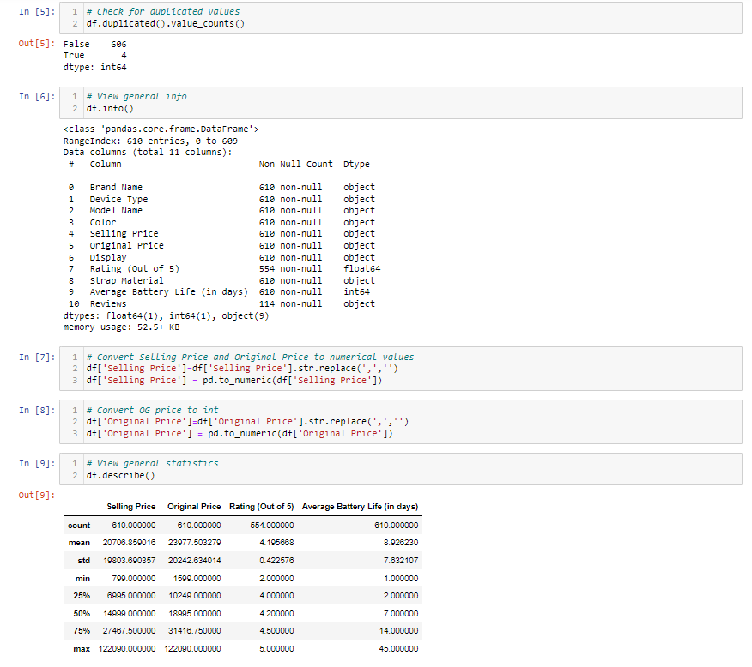

*Brands’ Popularity:*

* For this part, we are looking at how much coverage each brand has with its product:
  + Fossil seems to be the biggest player in the Indian market, followed by Garmin and Apple. This is interesting as a major player such as Fitbit did not see as much success as its reputation.
  + Other brands such as Samsung and Huawei seem to be branching out to this market as well.

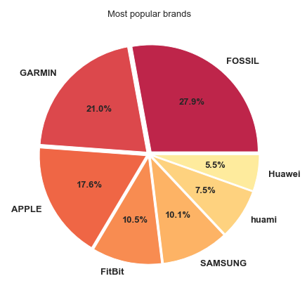

*Device’s Type Distribution:*

* The vast majority of devices available are smartwatches not fitness bands. This needs to be considered as Smartwatches are usually more expensive to produce, manufacture and provide support. Hence, we might want to think of the reasons why manufactures and consumers prefer this form factor.

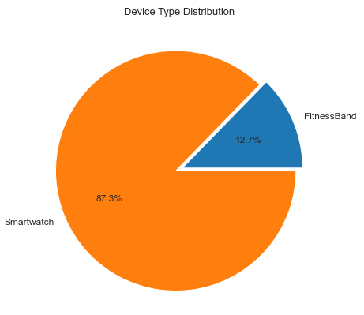

*Average Rating and Battery Life for each Device Type:*

* With this section, I am looking for any notable discrepancies between the device types in terms of battery life and rating scores:
  + The difference between average ratings between two type of devices are negligible, however the smartwatches do have a slight advantage.
  + The major difference can be observed when we are looking at average battery life, where smartwatches average nearly 10 hours while fitness bands often last around 7 and a half hours.

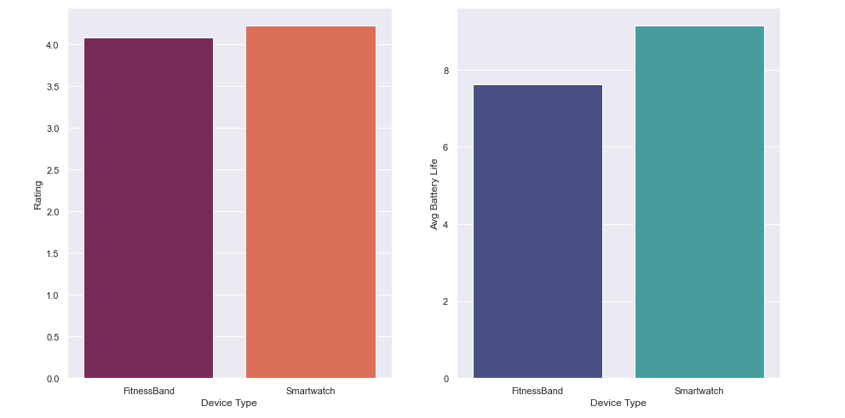

*Ratings Distribution Vs Selling Price and Discounted Percentages:*

* For this point, I am looking to see whether or not we can observe a focus distribution of ratings if we correlate them with the Selling Price or Discounted Percentage. I calculated a discounted percentage columns using the below formula and clean-up for format of our rating data.

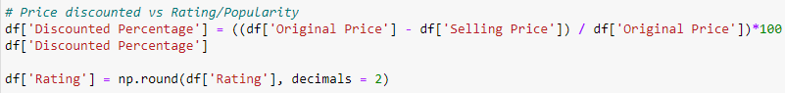

* Insights driven are as follow:
  + There is no clear correlation between the discounted percentages and the ratings given. This proves that the discount alone will not be enough for users to neglect the short-comings of products.
  + We can see that the majority of ratings between 4.0 to 4.3 lies between the selling price range of 0 to 30000 rupees (370 USD).
  + Highly priced products often see good rating scores although outliers do exist.

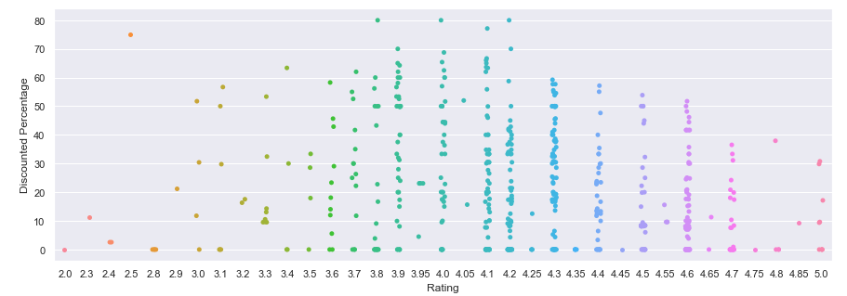

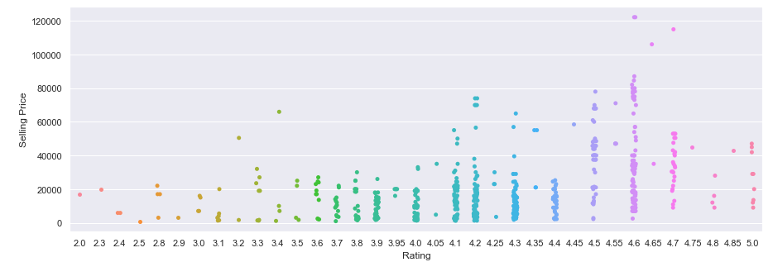

*Factor of Display Type:*

* Just as important, we are going to look at the visualizing different ways in which the screen types are affecting other attributes. Our first graph is the distribution of each display type for each type of devices, the second is the histogram for each screen variants and last is bar plot to correlate between screen types and ratings
* From the three, we can conclude the following:
  + The majority of smartwatches today use AMOLED displays, trailing in front of the amount that use OLED Retina displays.
  + Fitness bands, on the other hand, mostly came with equal distributions of AMOLED, OLED and PMOLED.
  + OLED Retina Displays are the favorite while AMOLED Displays have proven to be well received as well.
  + TFT-LCD, IPS, LCD and HD displays are the types with average rating over 4.0 with TFT-LCD Display is the far worst when it comes to ratings.

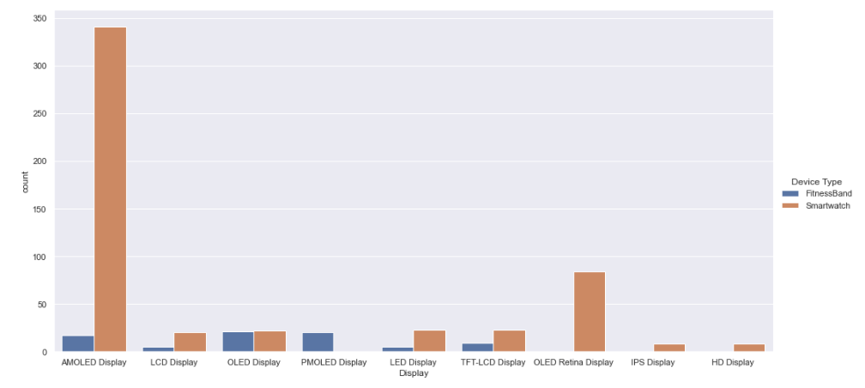

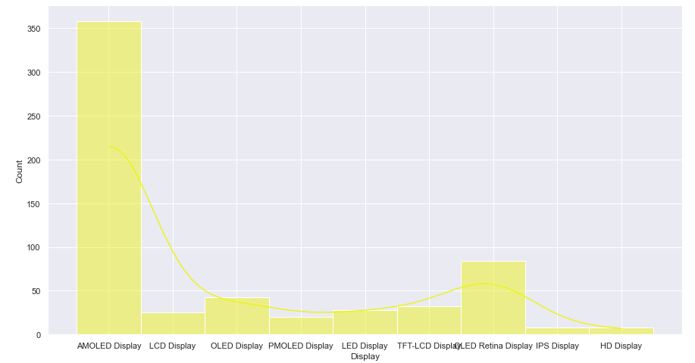

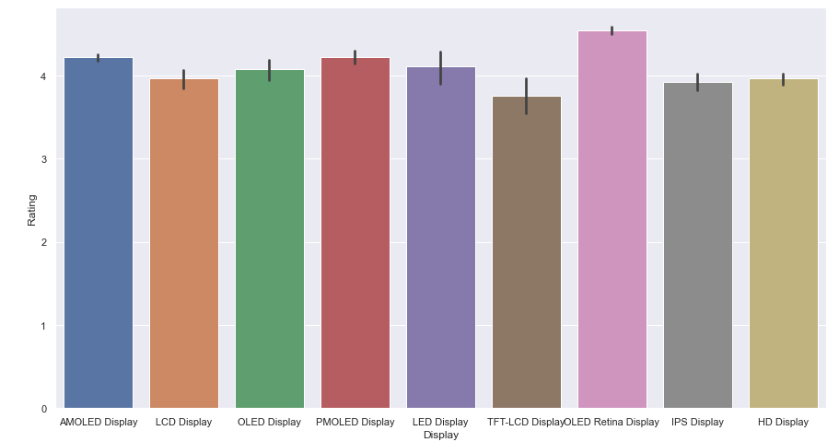

*Battery Life and Ratings:*

* Finally, we are going to look at how battery life will affect the consumers’ overall experience and reflected in ratings:
  + Besides the abnormality at the beginning with the average rating for 3-4 days of batter life at almost 4.0, we can see the trend here between average battery life and the rating.
  + As battery life increase, the average ratings also seem to rise up gradually.
  + The ratings peaked at around 4.6 for devices with over 40 days of run time.

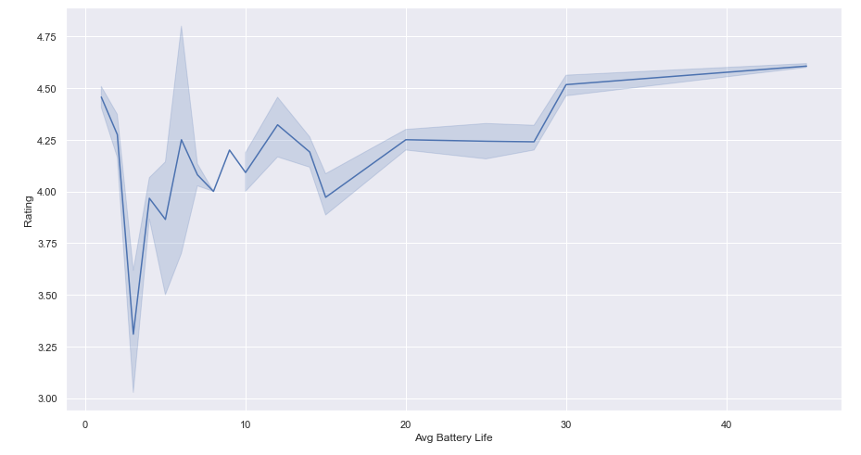

## 4. Summary, Suggestions and Recommendations

*Summary:*

To note, to fully understand this report, one must take brief view of the Jupyter notebook of the analysis and the reports does not fully cover all the analysis done. Thus the summary might contain some info outside of the scope of this report.

*Suggestion and Recommendations:*

We should be looking at the development of Smartwatches as the form factor seems to be well-received and is able to provide more functionality to users.

Battery life shows clear indication towards user's judgement for the products - suggesting that

Screen type is also an important to taken in mind of, the two most preferred choices are OLED Retina and AMOLED displays. On the other hand, we should avoid using TFT-LCD displays as it shown a significant difference of ratings between others.

Entry-level devices seem to be more approachable for users.